Power BI Assessment

Harsh Gaurav Batch: Shell7-SK-23-B4 Room no. 07

Executing Query in SQL Server Database 2014

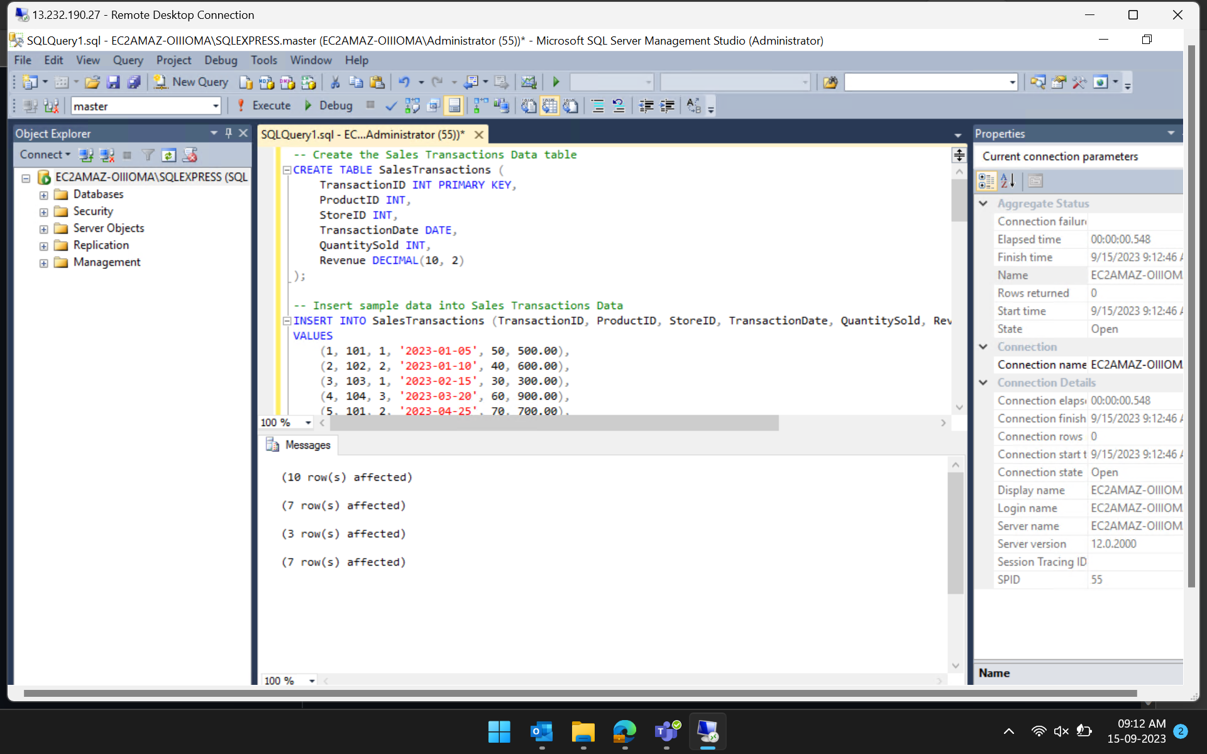

Loading Data from SQL Server

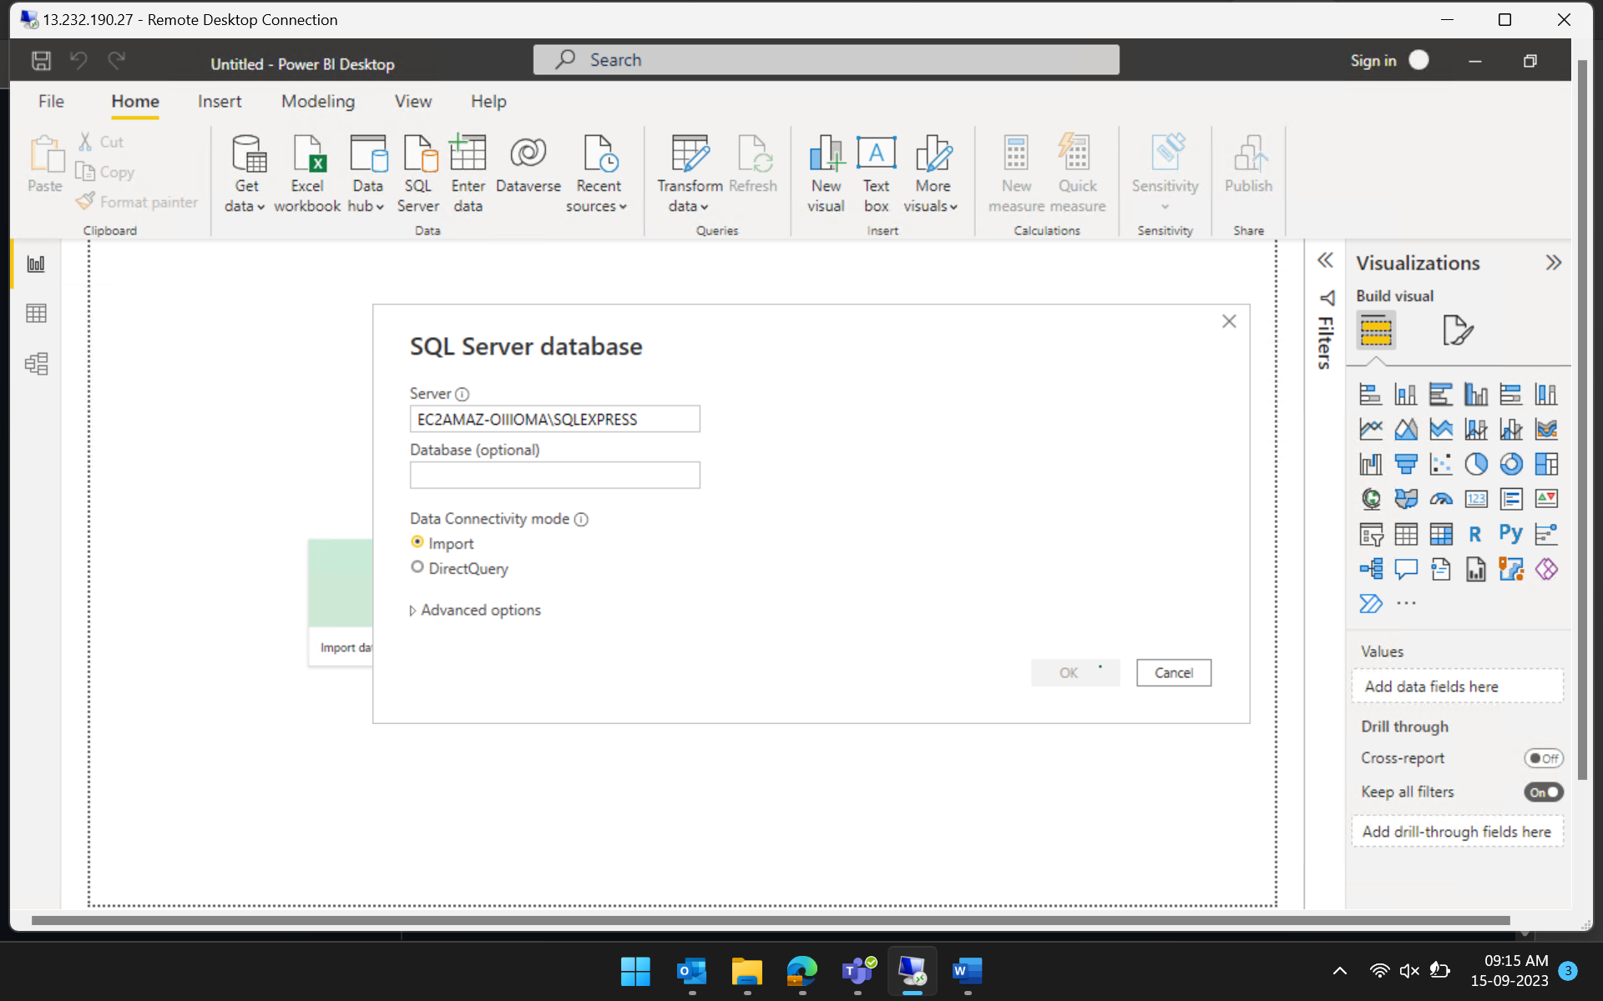

New database made and loaded

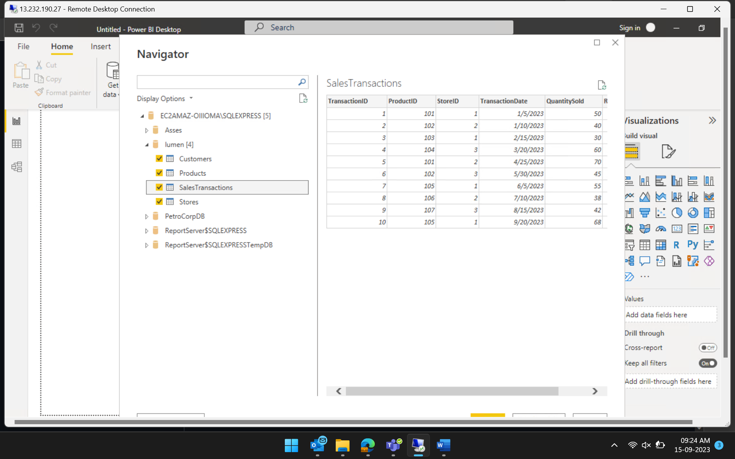

Making connections

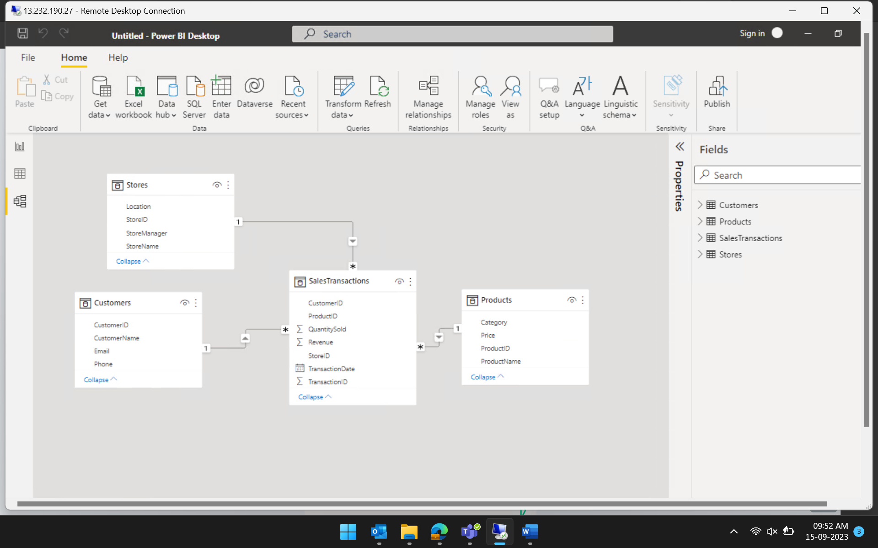

Clean Data:

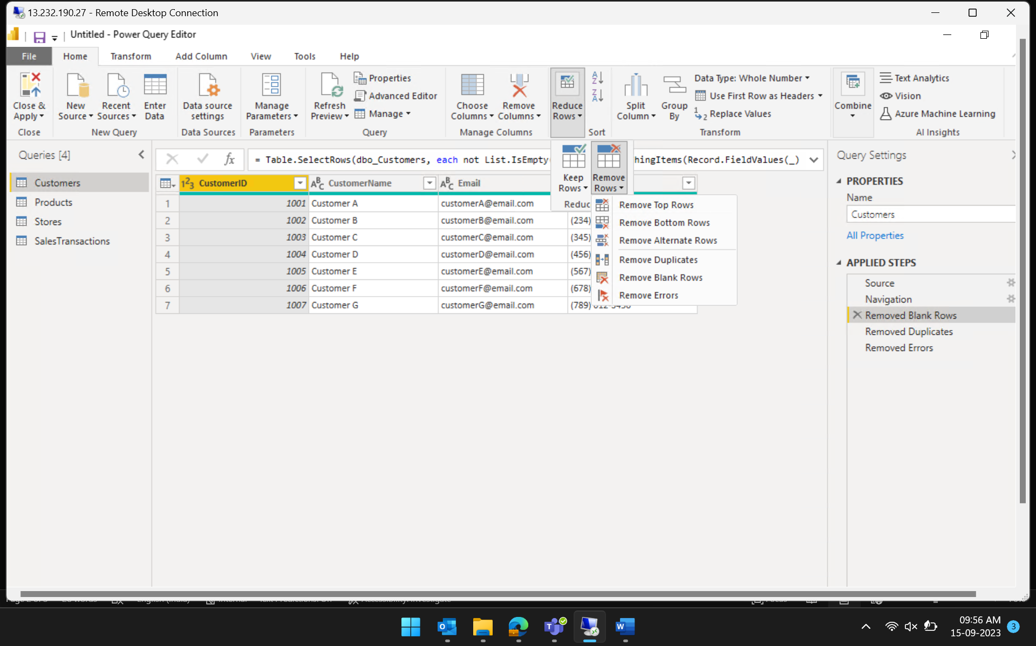

Create Calculated Columns:

Price per transaction made

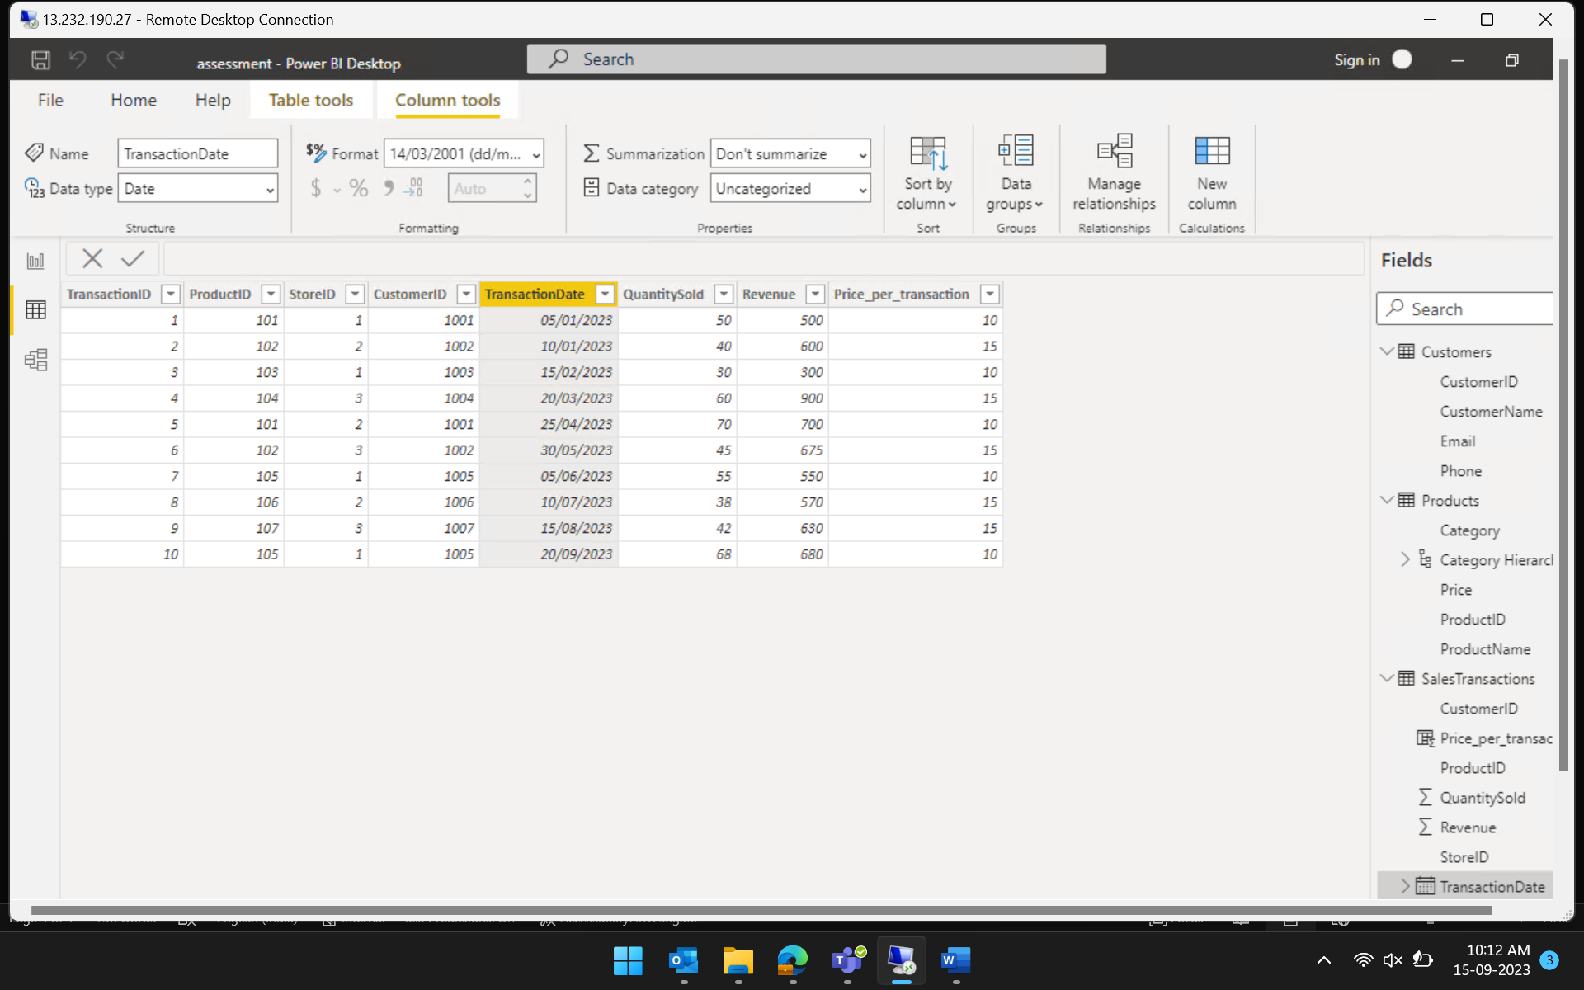

Filter Data:

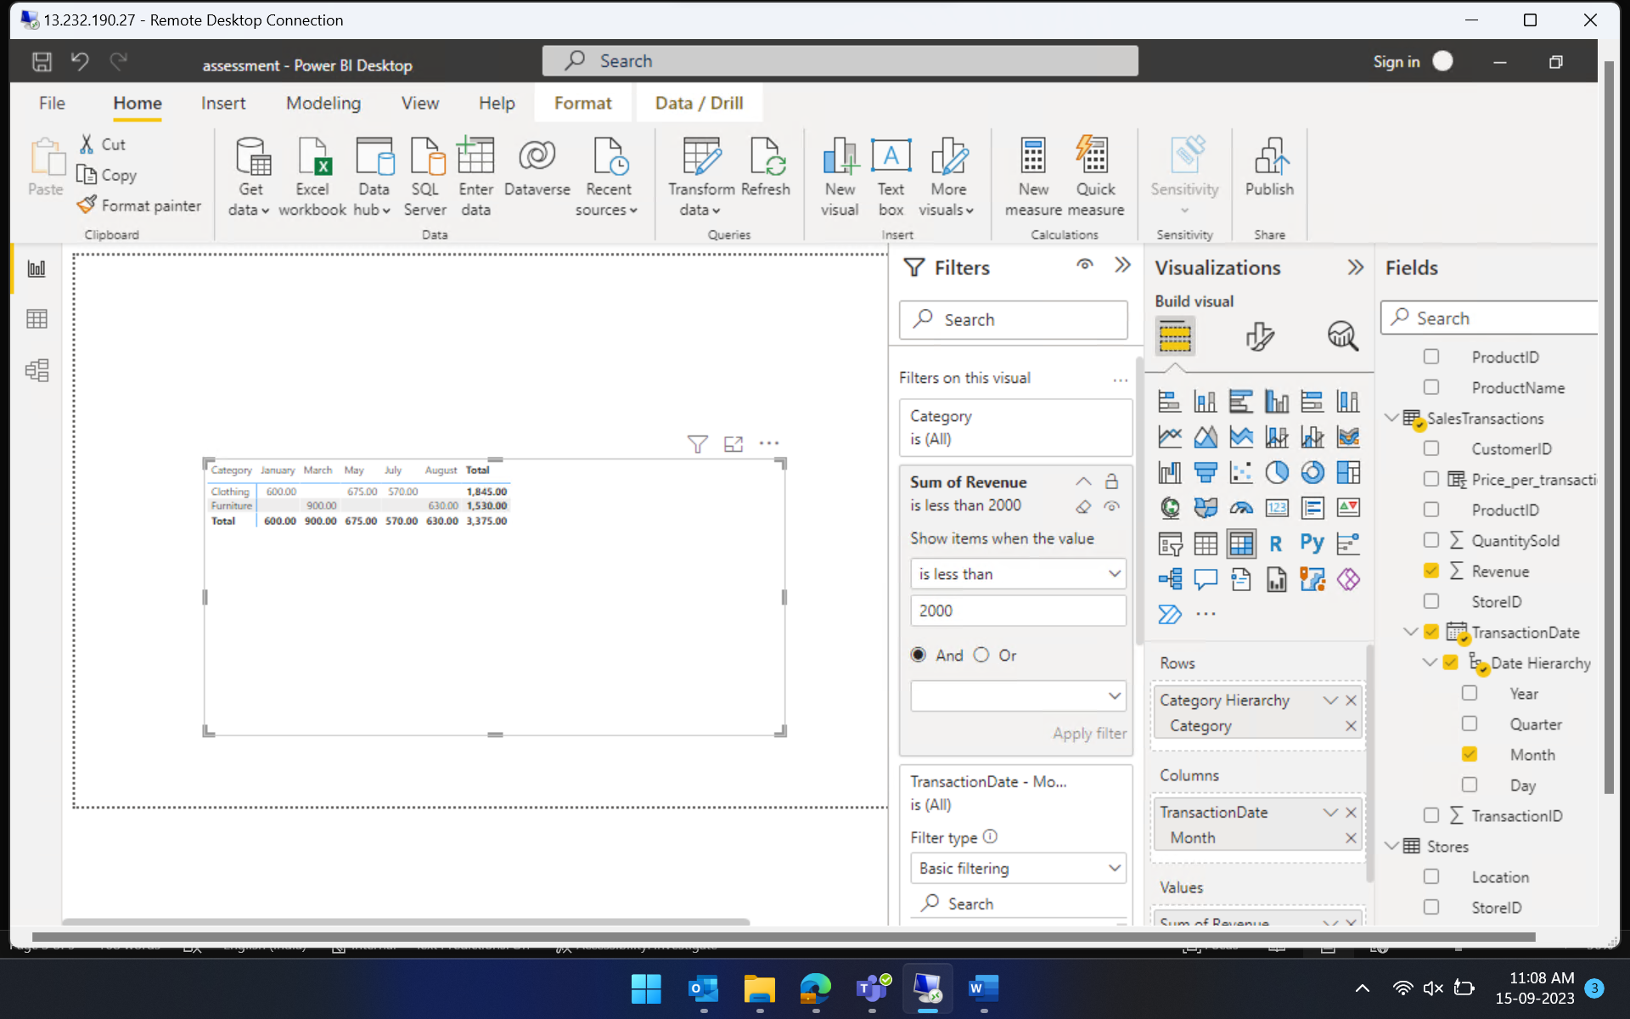

Create Relationships:



Create Hierarchies: (product hierarchy)

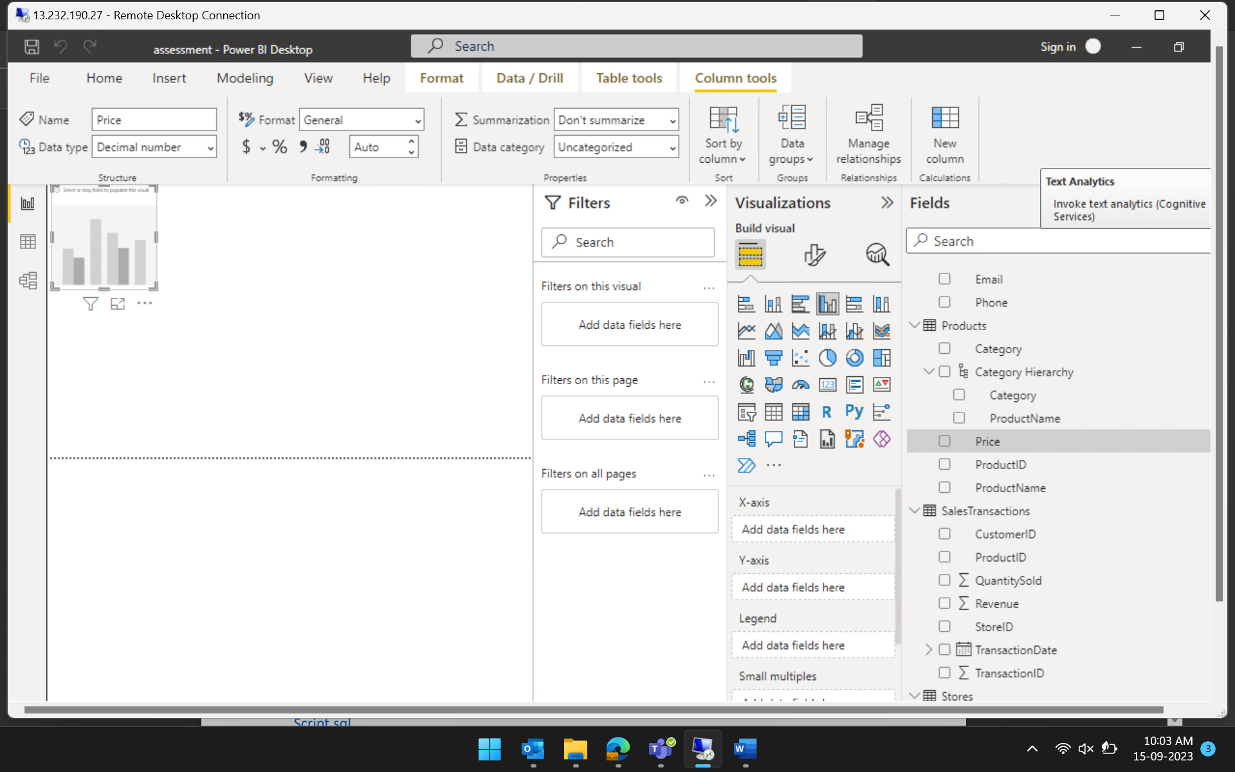

1. Who are the top-spending customers based on their total purchase amount?

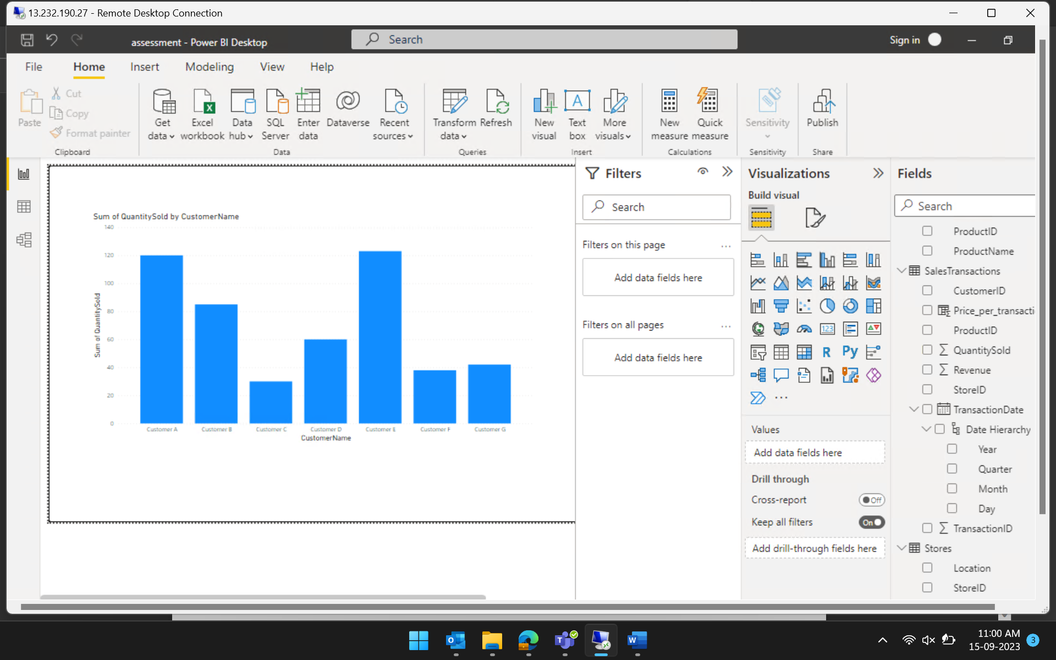

1. How is sales revenue distributed among different store managers?

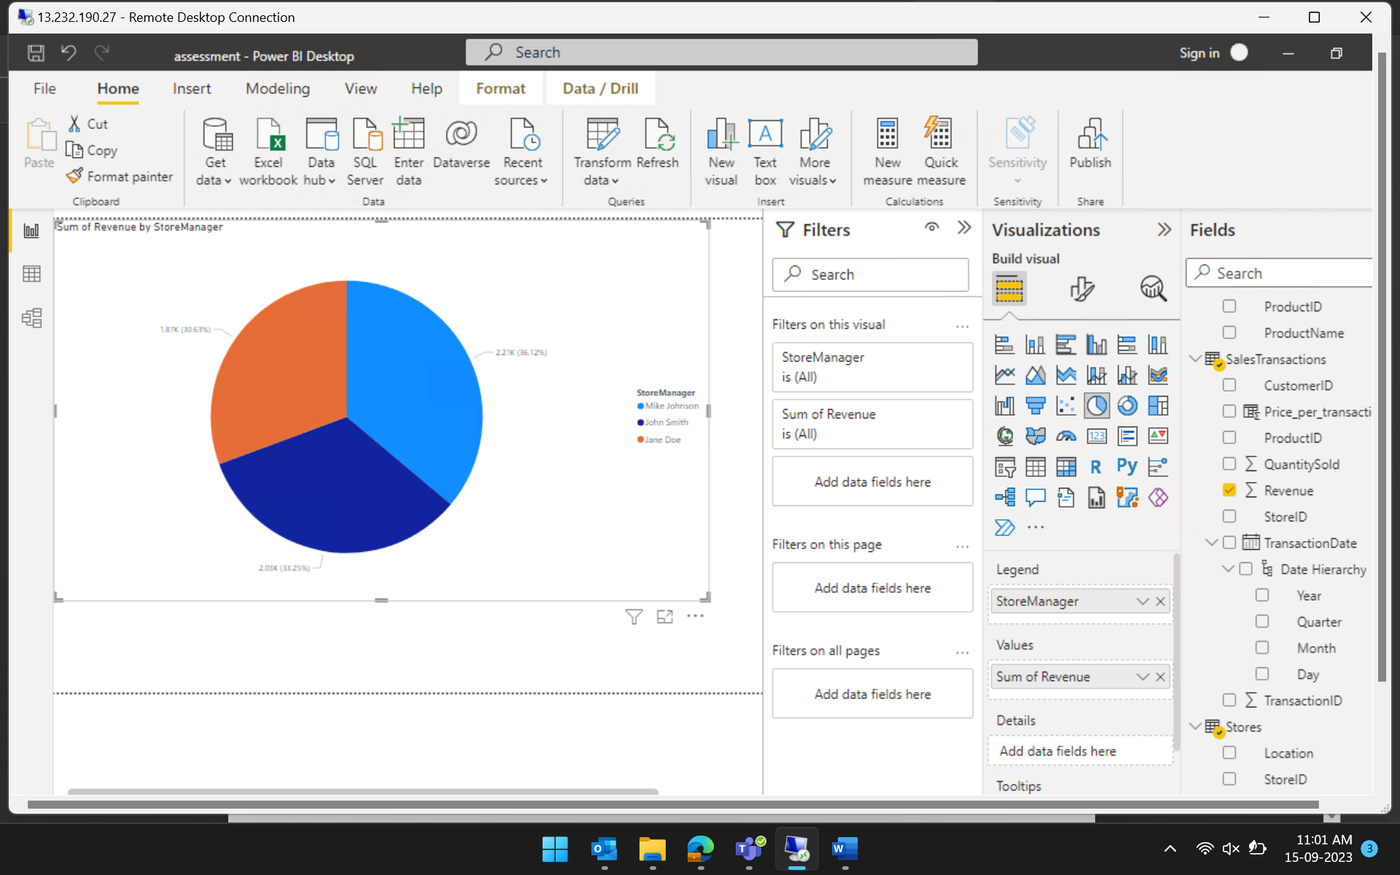

1. What is the average price of products in each category?

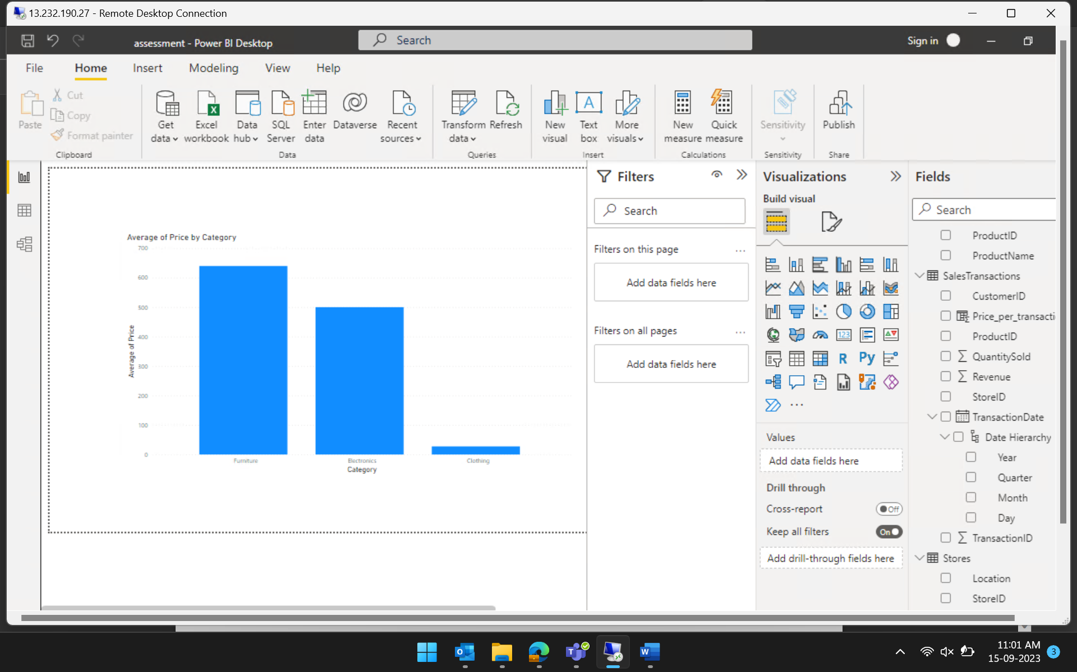

1. Are there specific days of the week when sales are higher?

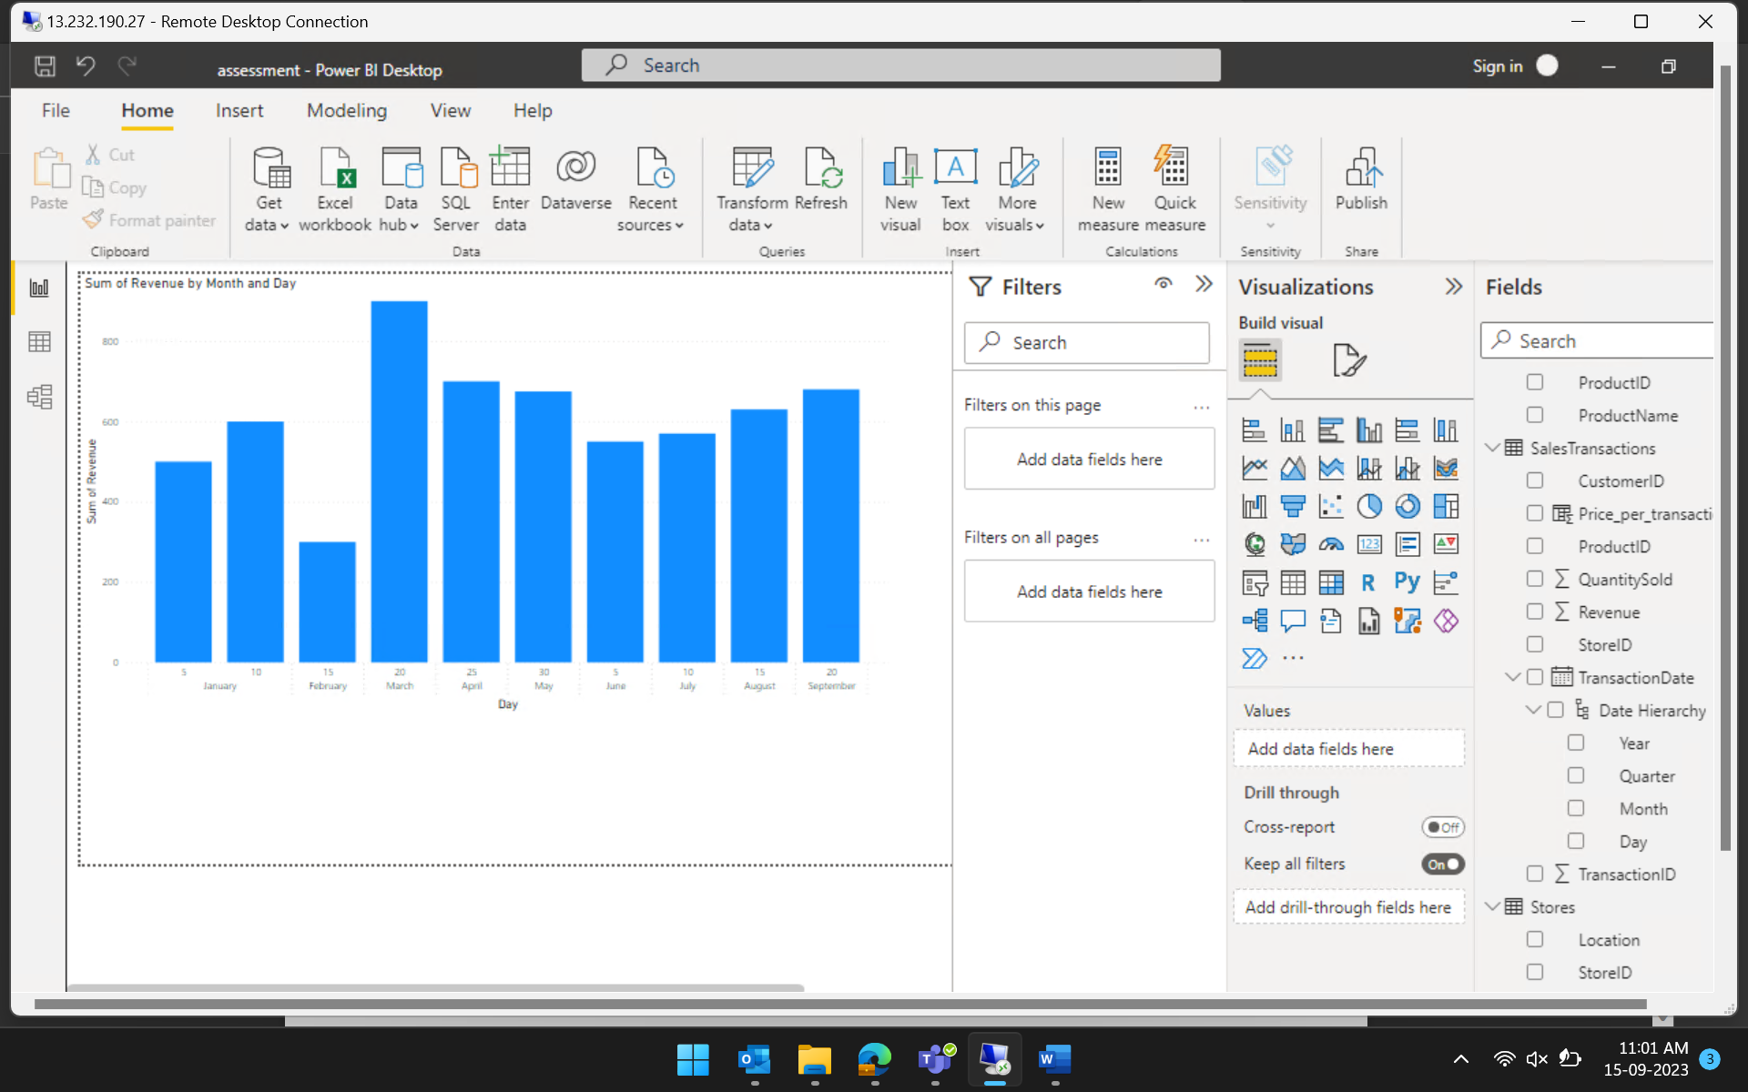

1. How do sales trends vary by product category on a monthly basis?

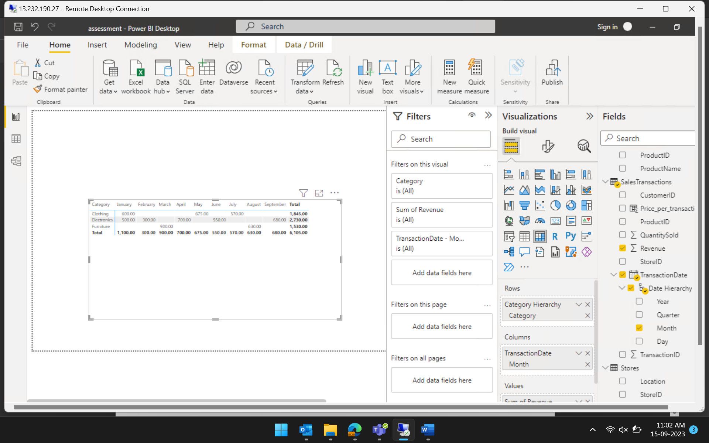

1. What percentage of products account for 80% of total sales revenue?
2. Are there any trends in repeat customer purchases?

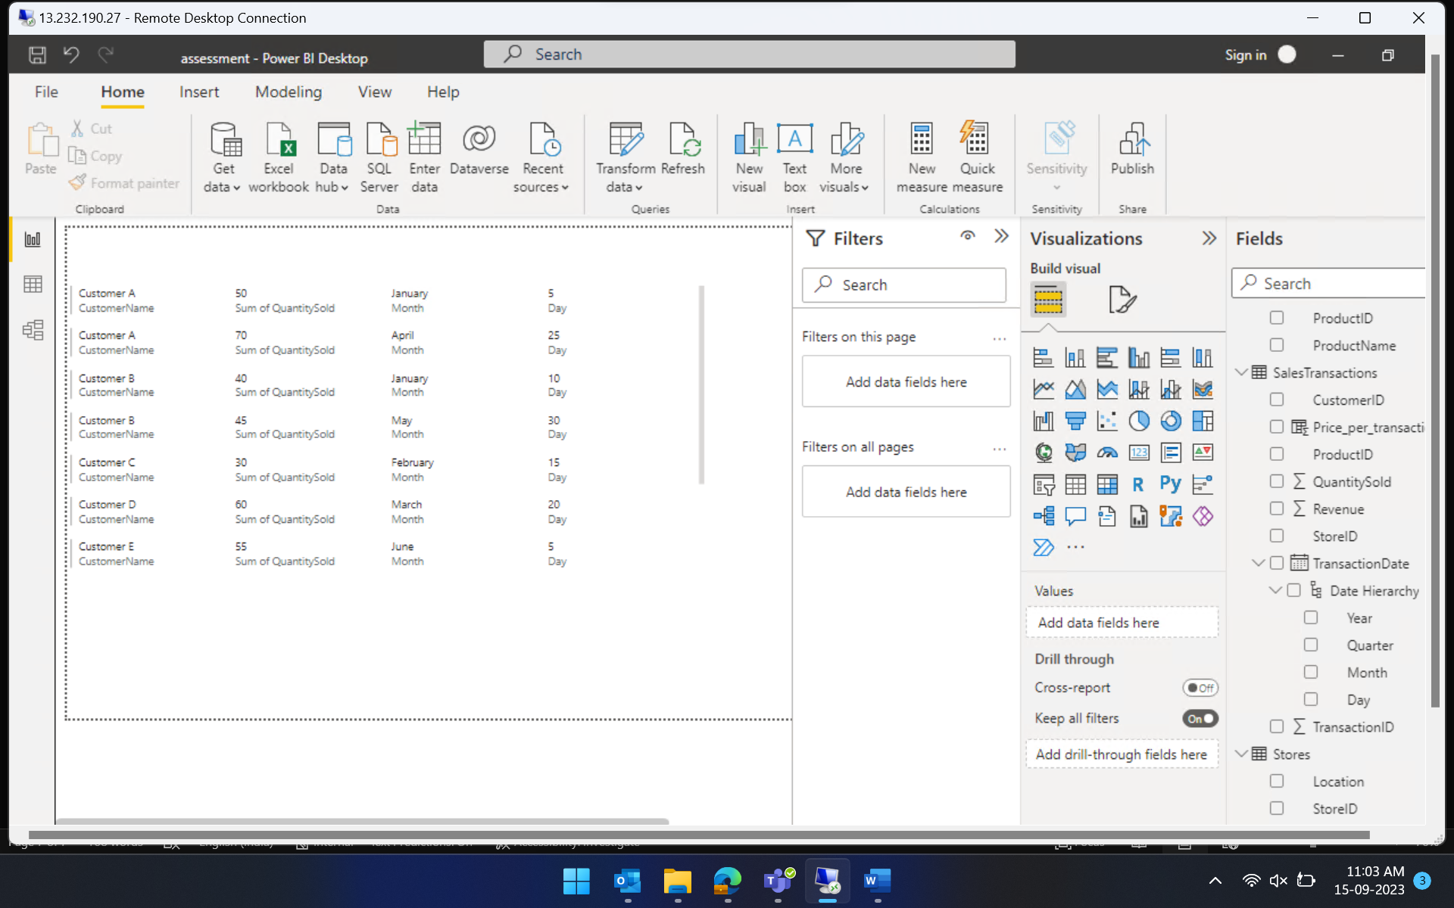

1. Which product categories perform best at each store location?

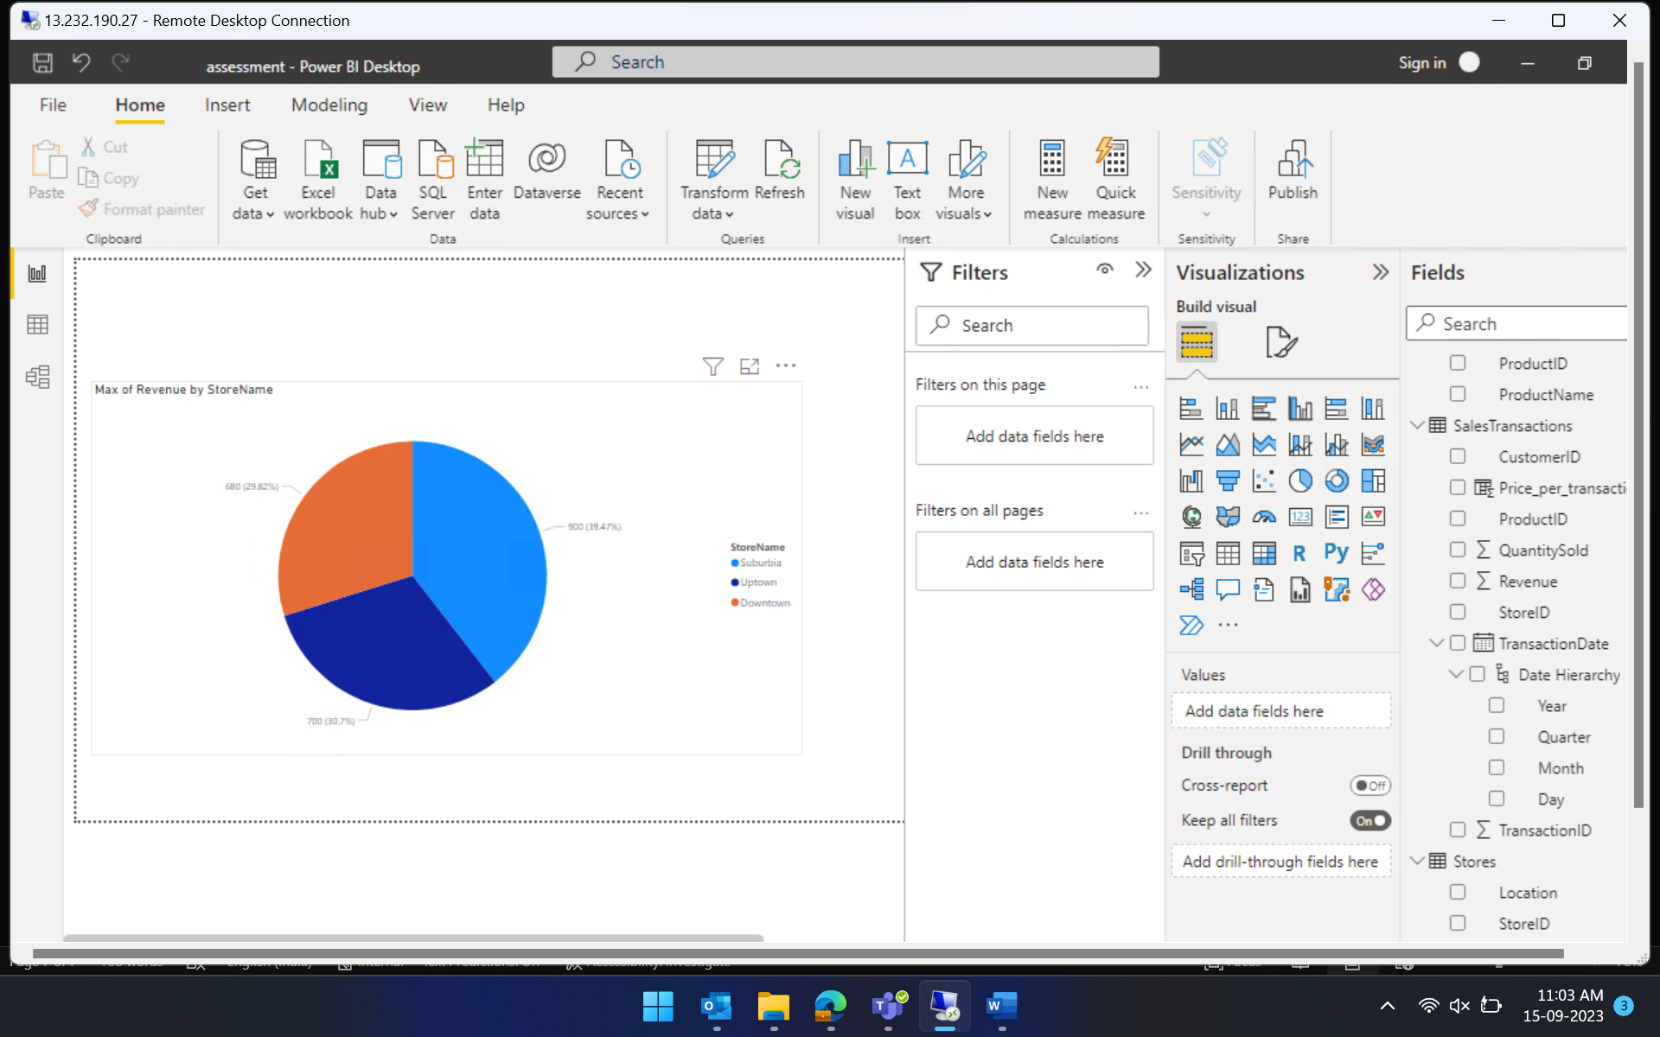

1. Are there any seasonal patterns or trends in sales for specific products or categories?

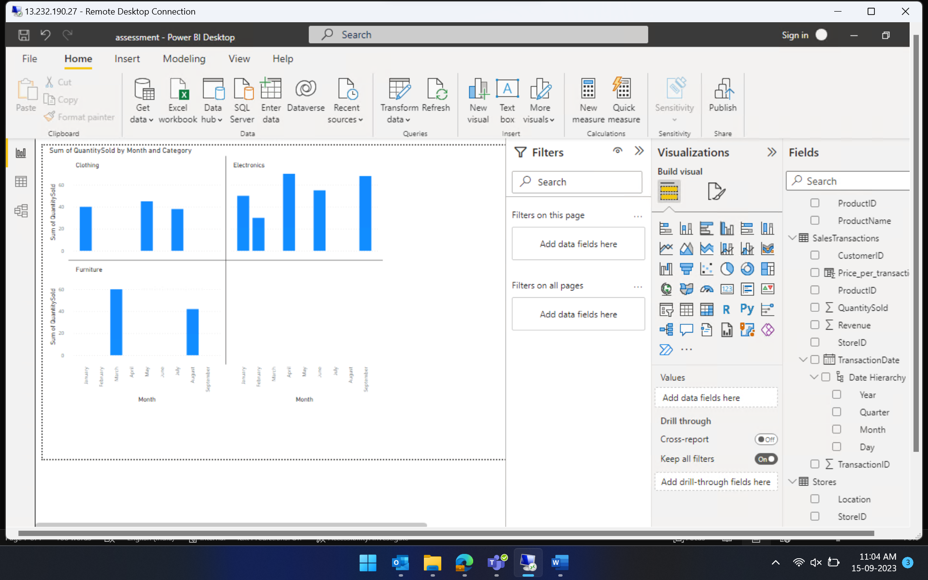

1. Can customers be segmented into high, medium, and low-value segments based on their purchase history.

